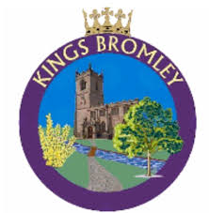
KINGS BROMLEY PARISH COUNCIL

Friday, 19th June 2026
Notice of Commencement of Public Rights to Inspect Accounts

Under Section 26 and 27 of the Local Audit and Accountability Act 2014, and in accordance with the Accounts and Audit Regulations 2015, electors and interested persons have the right to inspect the accounts of Kings Bromley Parish Council for the financial year ending 31 March 2026.

Inspection Period
The period for inspection commences on 22nd June and will conclude on 31st July lasting 30 working days.
During this time, any registered local government elector within Kings Bromley may:
- Inspect the accounting records and supporting documents.
- Ask questions to the appointed auditor, Kim Squires.
- Raise objections regarding any transaction within the accounts.

How to Access the Accounts
Inspection is available by appointment at a location within the Parish which will be booked for the purpose. To arrange an appointment, please contact:
- Parish Council Clerk and Responsible Financial Officer Jenny Procter
- Phone: 07504 501672
- Email: clerk@kingsbromley-pc.gov.uk

Auditor Details
The appointed auditor for Kings Bromley Parish Council is:
- Kim Squires
- Email: kimsquires2@gmail.com

